Abstract
This project presents the design and development of a Doctor Appointment Booking System using React.js, one of the most popular front-end JavaScript libraries for building modern, dynamic, and responsive user interfaces. The main objective of this system is to simplify and digitalize the process of booking medical appointments by providing patients with an easy-to-use online platform. Instead of visiting hospitals or clinics physically to schedule an appointment, patients can conveniently log in, browse through available doctors, check their details such as specialization and availability, and book a suitable time slot online.
The application is built using modular React components, which make the codebase clean, reusable, and easy to maintain. The integration of React Router enables smooth and seamless navigation between pages such as the home page, login, signup, doctor list, and booking form. To manage dynamic content and data flow efficiently, React Hooks like useState and useEffect have been implemented, allowing the app to update information in real-time without reloading the page.
Additional features include form validation to ensure correct input, localStorage integration to save user and appointment data persistently, and conditional rendering for managing different user states such as logged-in and logged-out views. These features make the application more reliable, interactive, and user-friendly.
This project emphasizes core front-end concepts such as component-based architecture, state management, event handling, and routing. It demonstrates how modern technologies like React.js can be effectively used to create interactive and real-time web applications. Beyond serving as a practical healthcare solution, this project also enhances the understanding of web development principles, user interface design, and client-side data handling.
Overall, the Doctor Appointment Booking System provides a convenient, efficient, and fully digital solution for managing doctor-patient interactions. It showcases how React.js can be leveraged to build real-world, responsive, and scalable web applications that make daily life tasks—such as healthcare appointments—faster, simpler, and more accessible to everyone.

Introduction

The Doctor Appointment Booking System is an advanced web-based application developed using React.js, designed to simplify and modernize the process of scheduling medical appointments. In traditional healthcare systems, patients often face challenges such as long queues, manual registration, and lack of real-time information about doctor availability. This project aims to eliminate these issues by providing a digital solution where patients can conveniently book appointments online from any location, at any time.
Through this system, users can sign up, log in, browse available doctors, view their specializations, and select a suitable date and time slot according to their preference. The interface is designed to be simple, responsive, and user-friendly, ensuring that even first-time users can navigate and book appointments effortlessly. By integrating key features like form validation, data storage, and instant confirmation, the system ensures a smooth and efficient booking experience.
Built entirely with React.js, the project utilizes its component-based architecture to maintain clean, reusable, and well-structured code. The use of React Hooks (such as useState and useEffect) allows for effective state management and real-time data updates without requiring page reloads. React Router has been implemented to handle smooth navigation between different sections such as home, login, signup, doctor list, and appointment forms.
The system also integrates localStorage to retain user data and login sessions, providing a persistent and personalized user experience. This ensures that users can continue their activities without re-entering their details after each session. The entire design emphasizes performance, interactivity, and scalability, making it suitable for future upgrades such as adding an admin panel, online payments, or doctor-side login modules.
Overall, the Doctor Appointment Booking System serves as a bridge between patients and healthcare providers by offering a convenient, reliable, and fully digital solution for managing appointments. It reflects how modern web technologies can transform traditional healthcare management into a fast, efficient, and user-oriented digital experience. By demonstrating practical concepts of front-end development, this project not only enhances user accessibility but also showcases the power and flexibility of React.js in building real-world applications.

Objectives
The primary objective of the Doctor Appointment Booking System is to develop a digital platform that simplifies and automates the traditional process of scheduling doctor appointments. This project aims to provide a modern, efficient, and user-friendly interface that allows patients to conveniently book appointments with their preferred doctors from the comfort of their homes.
In the traditional system, patients often face difficulties such as long waiting times, lack of information about doctor availability, and manual scheduling errors. To overcome these challenges, this project utilizes React.js, a powerful front-end library, to build a responsive, real-time, and interactive web application.
The project is designed with a focus on enhancing user experience, streamlining the appointment process, and reducing human effort. It demonstrates how modern web technologies can transform healthcare services by providing digital solutions that are accessible and efficient.
- To digitalize the appointment booking process:
Replace manual scheduling with an automated, online platform that can be accessed anytime and anywhere.
- To provide an intuitive and responsive user interface:
Use React.js components, hooks, and dynamic styling to create a clean and interactive UI that works smoothly on all devices.
- To enable secure user authentication:
Allow patients to create accounts, log in securely, and manage their profile and booking details.
- To display doctor information dynamically:
Provide details such as doctor name, specialization, availability, and consultation timing, helping users make informed decisions.
- To implement real-time appointment management:
Ensure that selected slots are updated immediately and that no overlapping or duplicate bookings occur.
- To demonstrate core React concepts:
Apply state management, event handling, conditional rendering, and React Router for seamless navigation between components.
- To enhance data persistence and reliability:
Use localStorage for saving user login data, appointment details, and other necessary information even after page reloads.
- To provide scalability and flexibility:
Design the system so that new features (like admin panel, payment gateway, or notifications) can be easily integrated in the future.
- To promote the use of modern front-end technologies in healthcare:
Showcase how React.js and modern web development techniques can contribute to building real-world, socially impactful applications.
- To improve patient-doctor interaction and accessibility:
Enable patients to connect with doctors easily, thereby saving time, reducing effort, and improving the overall healthcare experience.





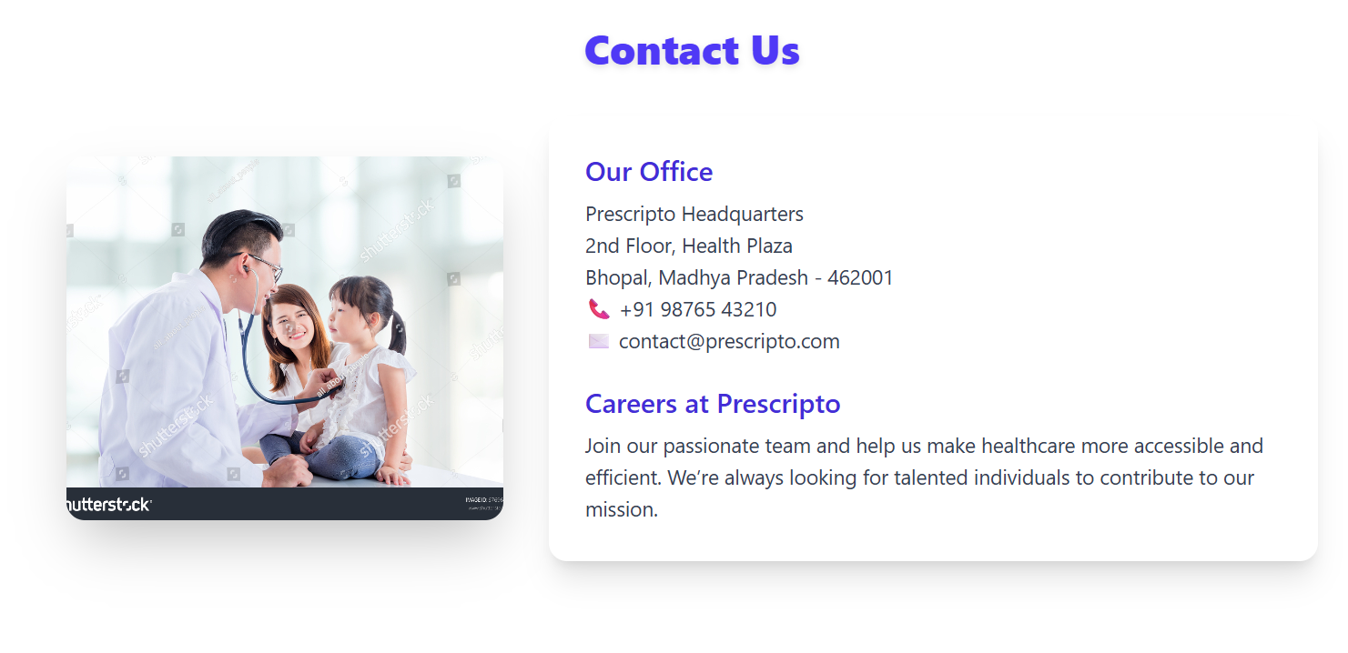

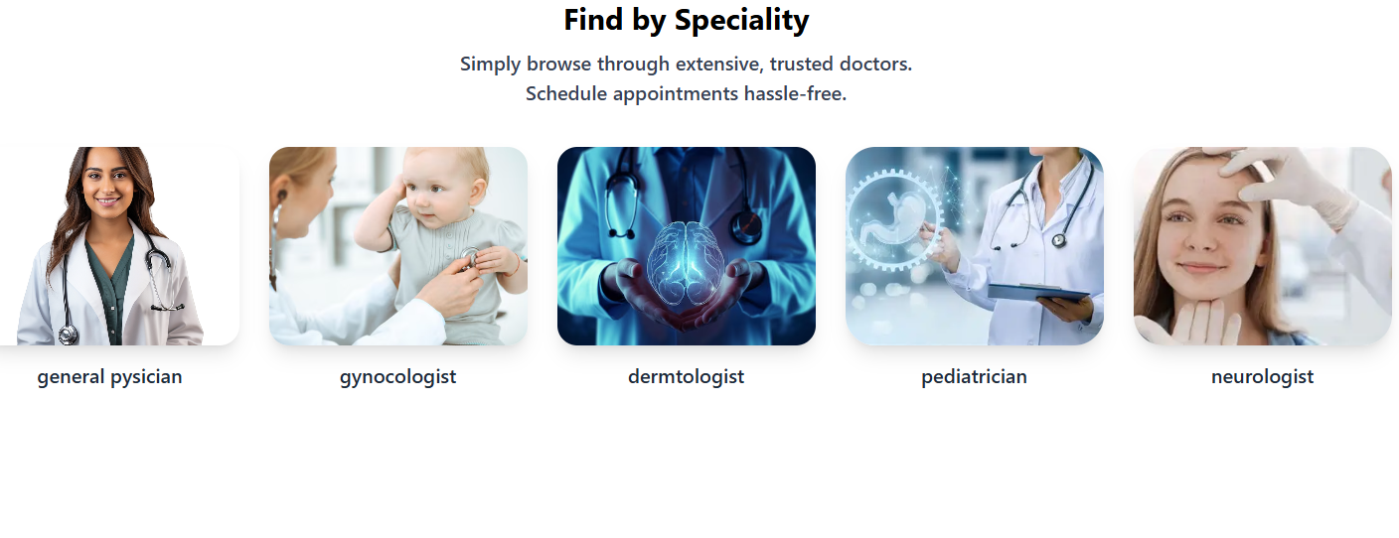
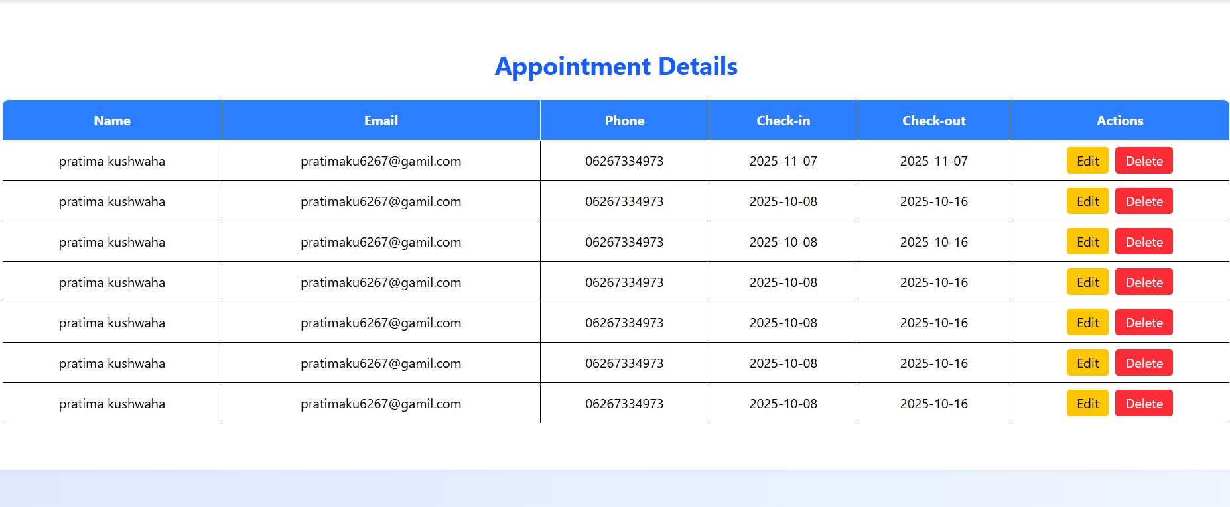

import React from "react";
import { Routes, Route, useLocation } from "react-router-dom";
import Navbar from "./Navbar";
import Footer from "./Footer";
import Signup from "./Signup";
import Login from "./Login";
import Alldoctor from "./Alldoctor";
import Contact from "./Contact";
import About from "./About";
// import Appointments from "./Appointments";
import Home from "./Home";
import Hero from "./Hero";
import Doc1 from "./Doc1";
import Doc2 from "./Doc2";
import Doc3 from "./Doc3";
import Doc4 from "./Doc4";
import Doc5 from "./Doc5";
import Doc6 from "./Doc6";
import Form from "./Form";
import Table from "./Table";

function Project() {
const location = useLocation();
const hideNavbarFooter = location.pathname === "/login" || location.pathname === "/signup";
return (
<>
{!hideNavbarFooter
<Navbar
logo="HOME"
link1="ALL DOCTORS"
link2="ABOUT"
link3="CONTACT"
link4="Prescripto"
link5="appoiment"
/>
)}

<Routes>

<Route
path="*"
element={
<>
<Home />
<Hero />
<Alldoctor />
<About />
<Contact />
</>
}
/>
<Route path="/Home" element={<Home />} />
<Route path="/Alldoctor" element={<Alldoctor />} />
<Route path="/About" element={<About />} />
<Route path="/Contact" element={<Contact />} />
<Route path="/Table" element={<Table/>} />
<Route path="/Doc1" element={<Doc1 />} />
<Route path="/Doc2" element={<Doc2 />} />
<Route path="/Doc3" element={<Doc3 />} />
<Route path="/Doc4" element={<Doc4 />} />
<Route path="/Doc5" element={<Doc5 />} />
<Route path="/Doc6" element={<Doc6 />} />
<Route path="/Form" element={<Form />} />

<Route path="/login" element={<Login />} />
<Route path="/signup" element={<Signup />} />
</Routes>

{!hideNavbarFooter && <Footer />}
</>
);
}

export default Projec

import React, { useState, useEffect } from "react";
import { Link, Outlet, useNavigate } from "react-router-dom";
import { FaBars, FaTimes } from "react-icons/fa";

const Navbar = (props) => {
const [menuOpen, setMenuOpen] = useState(false);
const [isLoggedIn, setIsLoggedIn] = useState(false);
const navigate = useNavigate();

useEffect(() => {
const loggedIn = localStorage.getItem("isLoggedIn");
setIsLoggedIn(loggedIn === "true");
}, []);

const handleLogout = () => {
localStorage.removeItem("isLoggedIn");
setIsLoggedIn(false);
navigate("/");
};

return (
<>
<nav className="w-full fixed top-0 left-0 bg-white shadow-md px-6 py-4 z-50">
<div className="flex items-center justify-between">
<h2 className="text-2xl font-semibold text-blue-600">
<Link to="/Home">{props.link4}</Link>
</h2>

<div
className="md:hidden text-2xl text-blue-600 cursor-pointer"
onClick={() => setMenuOpen(!menuOpen)}
>
{menuOpen ? <FaTimes /> : <FaBars />}
</div>

<ul className="hidden md:flex gap-8 items-center">
<li className="hover:text-blue-600 cursor-pointer">
<Link to="/Home">{props.logo}</Link>
</li>
<li className="hover:text-blue-600 cursor-pointer">
<Link to="/Alldoctor">{props.link1}</Link>
</li>
<li className="hover:text-blue-600 cursor-pointer">
<Link to="/About">{props.link2}</Link>
</li>
<li className="hover:text-blue-600 cursor-pointer">
<Link to="/Contact">{props.link3}</Link>
</li>
<li className="hover:text-blue-600 cursor-pointer">
<Link to="/Table">{props.link5}</Link>
</li>

{isLoggedIn ? (
<button
onClick={handleLogout}
className="bg-red-500 text-white px-4 py-2 rounded"
>
Logout
</button>
) : (
<Link to="/signup">
<button className="bg-blue-500 text-white px-4 py-2 rounded">
Signup
</button>
</Link>
)}
</ul>
</div>

{menuOpen && (
<div className="md:hidden bg-white shadow-lg rounded-b-lg mt-4 py-4 flex flex-col items-center space-y-4">
<Link
to="/Home"
className="hover:text-blue-600"
onClick={() => setMenuOpen(false)}
>
{props.logo}
</Link>
<Link
to="/Alldoctor"
className="hover:text-blue-600"
onClick={() => setMenuOpen(false)}
>
{props.link1}
</Link>
<Link
to="/About"
className="hover:text-blue-600"
onClick={() => setMenuOpen(false)}
>
{props.link2}
</Link>
<Link
to="/Contact"
className="hover:text-blue-600"
onClick={() => setMenuOpen(false)}
>
{props.link3}
</Link>
<Link
to="/Table"
className="hover:text-blue-600"
onClick={() => setMenuOpen(false)}
>
{props.link5}
</Link>

<Link to="/login" onClick={() => setMenuOpen(false)}>
<button className="bg-blue-500 text-white px-4 py-2 rounded-lg hover:bg-blue-600 transition">
Signup
</button>
</Link>
{/* <li className="hover:text-blue-600 cursor-pointer">
<Link to="/Table">{props.link5}</Link>
</li> */}

</div>
)}
</nav>
</div>
</>
export default Navbar;

Conclusion
The development of the Doctor Appointment Booking System using React.js has been an enriching experience that demonstrates the power and flexibility of modern web technologies in solving real-world problems. This project successfully simplifies the traditional process of booking doctor appointments by providing an online platform where patients can easily view doctors, check their availability, and schedule appointments from anywhere at any time.
Throughout the development process, important concepts of React.js such as component-based architecture, state management (useState, useEffect), routing with React Router, and data persistence using localStorage were effectively implemented. These features helped create a dynamic, interactive, and responsive user interface that ensures smooth user navigation and a better overall experience.
The project also highlighted the importance of user-friendly design, form validation, and data handling in web applications. It not only fulfilled its main objectives but also provided practical knowledge of how front-end frameworks can be used to develop real-time, responsive healthcare systems.
Overall, this project serves as a significant step toward understanding the fundamentals of React-based web development and showcases how technology can make healthcare services more accessible and efficient. It lays a strong foundation for future enhancements, such as integrating databases, admin dashboards, or online payment systems, to create a more comprehensive digital healthcare platform.
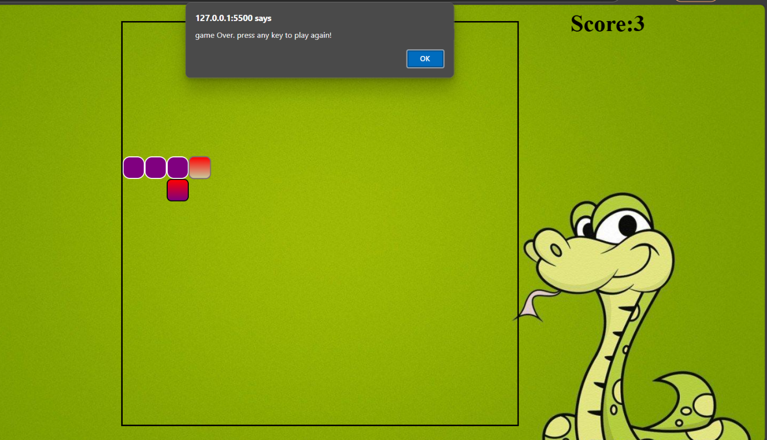Top of Form

Bottom of Form

